Addition of Integers
The addition of two positive integers is simply the sum of two positive numbers. For e.g. . 2+3 = 5.
The sum of two negative integers is the same except that the answer will take a minus sign. For e.g. (–2) + (–3) =
(2+3) = –5.
The when you have one positive and one negative integer, you must subtract, but answer will take the sign of the bigger integer. It is important to note that ignoring the signs of the numbers will decide which a bigger integer is.
For e.g.
(2) + (-1) = 2-1 = 1. 2> 1. Hence the answer is positive.
(2) + (-3) = 2-3 = -1. 3>2. Hence the answer is negative.
Numbers such as 3 and – 3, 2 and – 2, when added to each other give the sum zero. They are called additive inverse of each other.

Operations of addition and subtraction can also be done by using a number line.
When a positive number is added, we move to the right.
When a negative number is added, we move to the left.
When a positive number is subtracted, we move to the left.
When a negative number is subtracted, we move to the right.
blem: Use number line and add the following integers: 9 + (– 6)
Solution:
This can be shown on the number line as follows:
- For addition of a positive integer, we first we move 9 steps to the right of 0 reaching +9.
- From this point we move 6 steps to the left, since a negative number is being added.
- We reach the point +3. Thus, (9) + (-6) = +3.
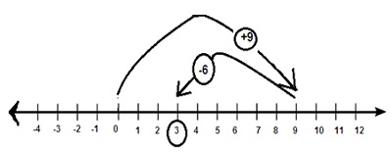
Problem: Use number line and add the following integers: (– 1) + (– 7)
Solution:
On the number line, we first move 1 step to the left of 0 reaching -1.
Since two negative numbers are being added, we move left twice. From the point of -1, we further move 7 steps to the left of – 1 and reach – 8.
Thus, (– 1) + (– 7) = – 8.
